A mathematical model of the slow-wave electrical activity of the human small intestine*
B. Robertson-Dunn D. A. Linkens
Department of Control Engineering, University of Sheffield, Sheffield, Yorks, England
Abstract - Based on available data of the slow-wave electrical activity in the small intestine of humans and dogs, a mathematical model has been developed. The model comprises an interconnected chain of 100 Van der Pol relaxation oscillators with the method of coupling and its magnitude chosen so that known phenomena in the small intestine are reproduced by the mathematical model. Results from digital simulations on an IeL 1907 computer are presented which show ho w the model matches the data from the small intestine. Further phenomena such as a travelling area of reduced frequency along the oscillator chain have also been found, and it is shown that this effect is related to the phase relationships along the chain.
Keywords - Electrical activity of the human small intestine
Introduction
THE PRESENCE of electrical activity in the human small intestine has been known since recordings were first made by ALVAREZ (1921). He observed that the electrical activity had a frequency of oscillation of about 12 cycles per minute, which has been called the 'basic electrical rhythm' or the 'slow waves'. As well as this slow-wave electrical activity there was also discovered a faster, spike activity which has been shown to be correlated with the contraction of the intestinal smooth muscle, In recent years work has been done to investigate the causes of electrical activity patterns and their controlling effect on the digestive tract. Much of the work has been done on dogs from which electronic and mathematical models of the slow-wave electrical activity have been postulated. The basis of the models has been the work of VAN DER POL (1928) who suggested that many naturally occurring rhythmic oscillations are the result of a relaxation phenomenon. He proposed a differential equation which describes such oscillations, and modified forms of this equation have been applied to the problem of modelling the intestinal slow wave.
The concept of a chain of linked relaxation oscillators has been used by several groups to model the small intestine. NELSEN and BECKER (1968) began with two oscillators on an analogue computer and SARNA, DANIEL and KINGMA (1971) advanced this using 16 analogue oscillators in their model with additional terms in the Van der Pol equation to allow for asymmetrical slow waves. Also working on this problem have been DIAMANT, ROSE and DAVISON (1970), who used a digital computer and modelled with 25 oscillators. However, the two groups have used different coupling between the oscillators. SARI'<A et al. have used symmetrical coupling between oscillators; i.e. oscillator A affects oscillator B as much as oscillator B affects oscillator A.
On the other hand, DIAMANT et al. have used unidirectional coupling so that oscillator B will not affect oscillator A at all. The model DIAMANT described failed to show that when the oscillators are coupled together they all have a higher frequency than when uncoupled. He had to increase the frequency of his fastest proximal oscillator in order to achieve the required effect.
The models described so far have been based on data obtained from dogs and have been limited in the number of oscillators available. The object of this paper is to describe a model, based on human data, using 100 oscillators programmed on a digital computer. It is believed that this model successfully agrees with known human data and shows a phenomenon which may explain the co-ordinating role played by the electrical slow wave.

Intestinal slow-wave data
The data from which the parameters in the model have been estimated have come from several sources. The first was the group at the Department of Surgery at Sheffield University, who have made measurements on human patients (BROWN, KWONG, DUTHIE, WHITTAKER and FRANKS, 1971; BROWN, DUTHIE, FRANKS, LINKENS and ROBERTSON-DUNN;, 1972; DUTHIE, KWONG, BROWN and WHITTAKER, 1971; DUTHIE, BROWN, ROBERTSON-DUNN, KWONG, WHITTAKER and WATERFALL, 1972; WATERFALL, BROWN, DUTHIE and WHITTAKER, 1972). Other details were obtained from published data on humans by CHRISTENSEN, SCHEDL and CLIFTON (1964, 1966a, 1966b), HOLADAY, YOLK and MANDELL (1958) and LABO, LANFRANCHI, BORTOLOTTI, MIGLIOLI and BARBARA (972).
Human electrical recordings have been made by the Department of Surgery, Sheffield, using two techniques. The first was to implant electrodes into the duodenal serosa at the time of an abdominal operation. The second method was to pass, through the mouth or nose, a tube containing two electrodes 50-100 mm apart which were sucked on the mucosa of the duodenum. This method was also used in the terminal ileum through an ileostomy. Only two channels of electrical data and two channels of pressure data were obtained. A further disadvantage was that the exact position of the electrode was not always known.
CHRISTENSEN, SCHEDL and CLIFTON (1964. 1966a, 1966b) have also used the tube method, although they only had a single electrode and allowed the tube to pass steadily along the intestine to the terminal ileum. They reported that the frequency decreases in an irregular manner and term it a stepwise gradient. In order to establish the form of the frequency gradient, it is strictly necessary to make many simultaneous recordings along the whole length of the small intestine. This, unfortunately, has never been reported in man. Since the recordings were obtained in a sequential manner over a long period of time it is difficult to be sure about the relative frequencies between adjacen t parts of the bowel A frequency plateau has been found in the duodenum with a rate of about 12 cycles/min (DUTHIE, KWONG, BROWN and WHITTAKER, 1971). Terminal ileal recordings have shown a slow-wave rhythm of 6·5 to 9.3 cycles/min (WATERFALL, BROWN, DUTHIE and WHITTAKER, 1972). We have chosen 7 cycles/min for the purposes of the model. Intermediate values between these areas have been taken from CHRISTENSEN, SCHEDL and CLIFTON (1966a) and LASO, LANFRANCHI, BORTOLOTTI, MIGLIOU and BARBARA (1972).
Areas of intense spike activity migrating down the small intestine of dogs have been described by SZCRSZWESKI (1969). He observed a caudad moving band of large-amplitude action potentials (referred to as the electric complex) which started in the duodenum and traversed the small bowel. When one complex reached the ileum another was developing in the duodenum and proximal jejunum. He called this motor complex the interdigestive housekeeper of the small bowel. It is not known if this phenomena is found in man or what relationship it holds with the workings of the small intestine when food is present.
Transections at different points along the small intestine in dogs have shown that, when cut, the distal slow waves decrease in frequency (HERMANTAYLOR and CODE, 1971).

The mathematical model
The mathematical model comprises 100 self-oscillatory units connected in a chain as shown in Fig. 1.
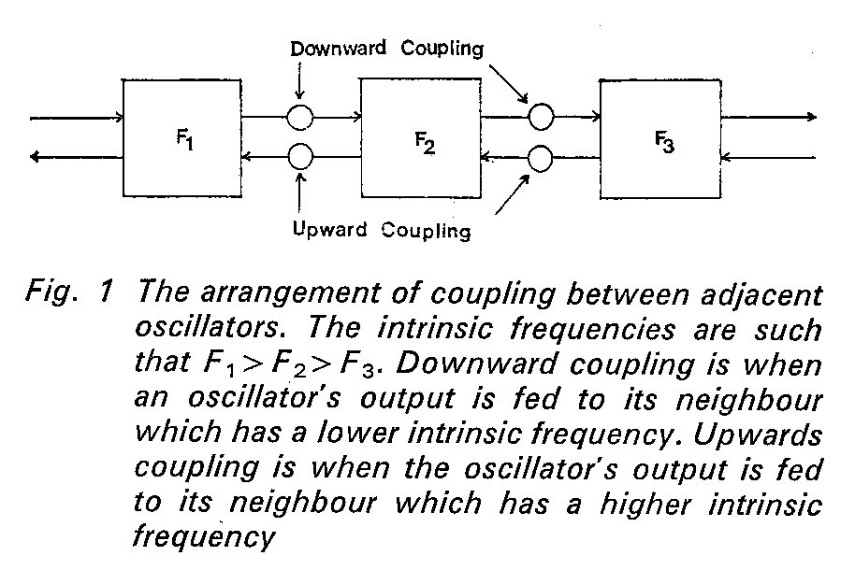
The basic unit was chosen to be self-oscillatory since it has been found that small isolated areas of intestinal tissue are capable of producing slow waves. The model for each unit is based on the Van der Pol equation (VAN DER POL and VAN DER MARK, 1928)
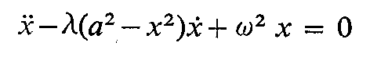
In contrast to gastric slow waves the intestinal signals are nearly sinusoidal and a waveshape parameter λ of 1·0 was chosen to give a model waveform similar to human duodenal recordings. The amplitude parameter a is constant at 1.0 along the model chain, while the uncoupled frequencies are determined by the values of ω.
Based on data mentioned in the previous Section, the uncoupled frequency of the first most proximal oscillator is 12 cycles /min, and for the most distal oscillator representing the terminal ileum the frequency is 7 cycles/min. Along the first 20 oscillators the uncoupled frequency decreases linearly 40% of the total frequency drop. The remaining 60% of the frequency drop occurs linearly over the remaining 80 oscillators. The uncoupled frequency is given approximately by:
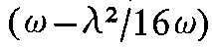
To ascertain a suitable form of connection between the oscillators various bidirectional coupling methods were investigated on a high-speed Applied Dynamics AD4 analogue computer. The two first-order differential equations for the nth oscillator in the chain may be written as
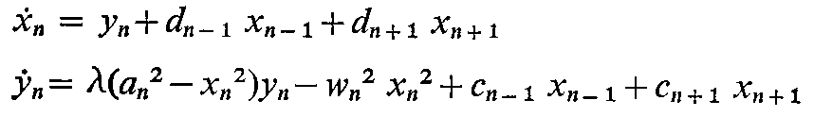
where the d and c coefficients represent different forms of coupling, and the suffix (n-1) indicates downward coupling and suffix (n +1) indicates upward coupling.
It was found that the x to dx/dt bidirectional coupling represented by the d coefficients did not give an increase in frequency above the highest uncoupled frequency in the chain. If two oscillators of equal uncoupled frequency are coupled symmetrically in this manner it can be shown analytically (D. A. LINKENS) that the oscillators become entrained together at a common frequency given by:
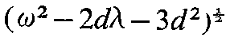
which is always less than the uncoupled frequency and hence does not agree with the available data. The x to d²x/dt² bidirectional coupling represented by the c coefficients, however, does give an increase in frequency, and it can be shown that there are now two stable oscillations of frequency
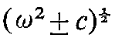
for two equal oscillators. The increased frequency is given when the oscillators are entrained in antiphase, while an inphase entrainment gives a decreased frequency. To avoid the condition of multiple solutions for the mathematical model, asymmetrical bidirectional x to d²x/dt² coupling was finally chosen for the chain model.
The 100-osciliator model was simulated on an ICL 1907 digital computer using a Runge-Kutta integration routine. A step length equivalent to 0.25s was used, which represents about 20 integration steps per cycle for the fastest oscillators. Printout of model results included graphs of average frequency versus oscillator number for 1 min and 5 min periods. The occurrences of the oscillator outputs passing through zero from positive to negative values were plotted against time, as also were instantaneous phase and frequency information. Examples of these displays will be given in the following Section.
The model was set up with the uncoupled frequency gradients already mentioned and the simulation run with various values of coupling parameters. A suitable increase in entrained frequency above 12 cycles/min together with an entrained plateau of 13 oscillators at the distal end of the chain, and a stable solution was obtained with a ratio of downward to upward coupling of 5 0. The downward coupling was 0.4 at the distal (high-frequency) end and 0.2 at the proximal (low-frequency) end. The gradient for the coupling drop was chosen in the same way as for the uncoupled frequencies.
Results
The average frequencies of the coupled 100-oscillator model. measured over a period of 5 min, are shown in Fig. 2.
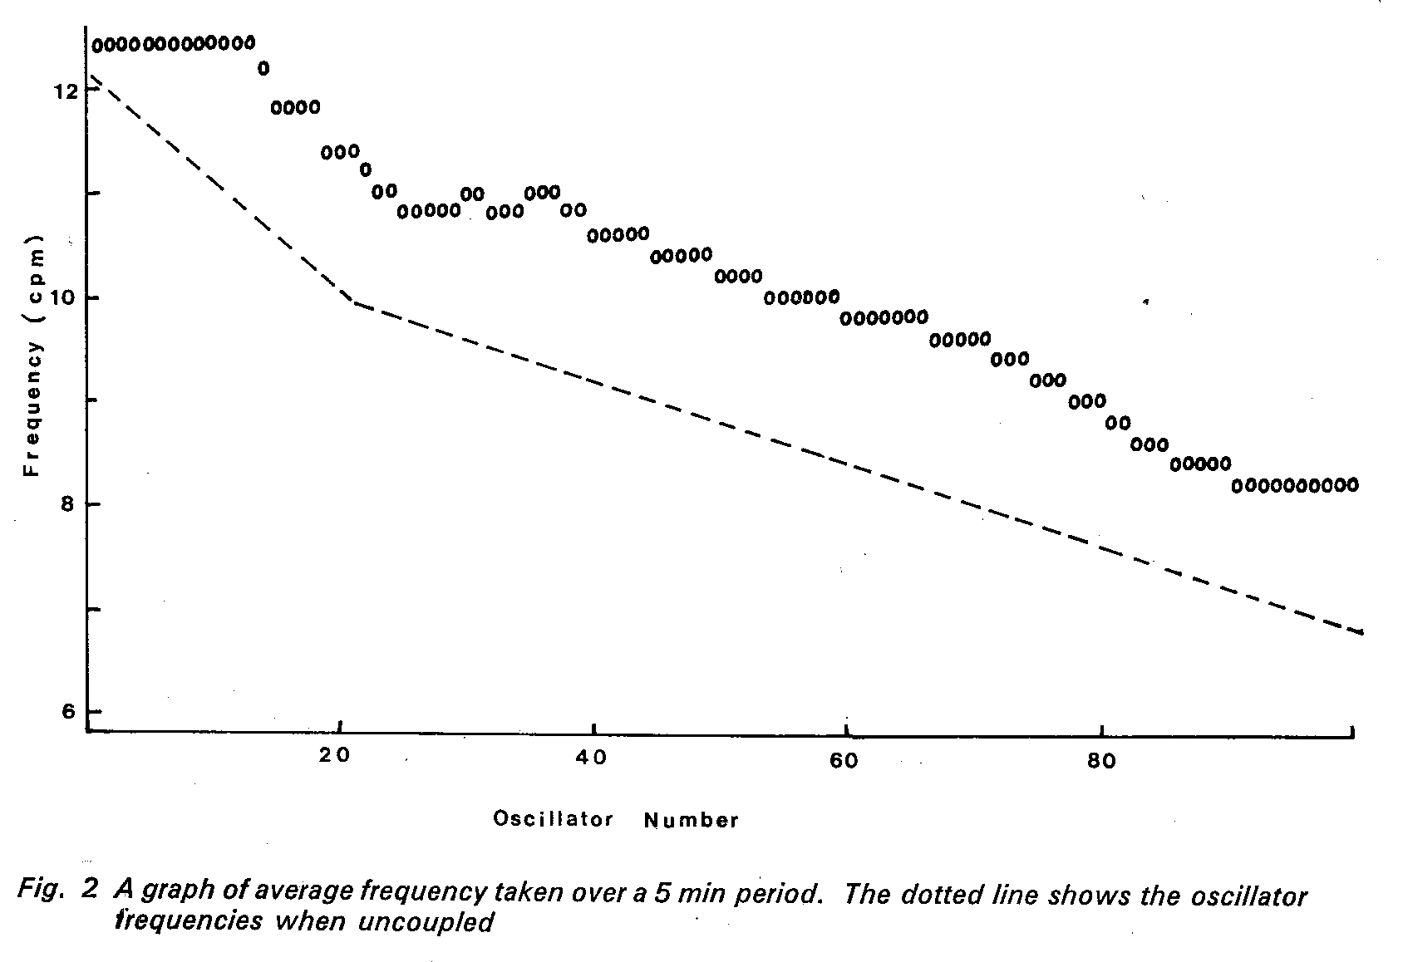
The chain at the high-frequency proximal end formed a frequency plateau with the oscillators locked in frequency and phase. This frequency was higher than the uncoupled frequency of the fastest oscillator. The remaining oscillators showed a varying frequency gradient which could fit in with the concept of a series of short frequency plateaus along the small intestine giving the stepwise gradient of CHRISTENSEN et al. (1964). The result of cutting the chain after oscillator 15 to simulate a transection of the small intestine is shown in the 4 min average of Fig. 3.
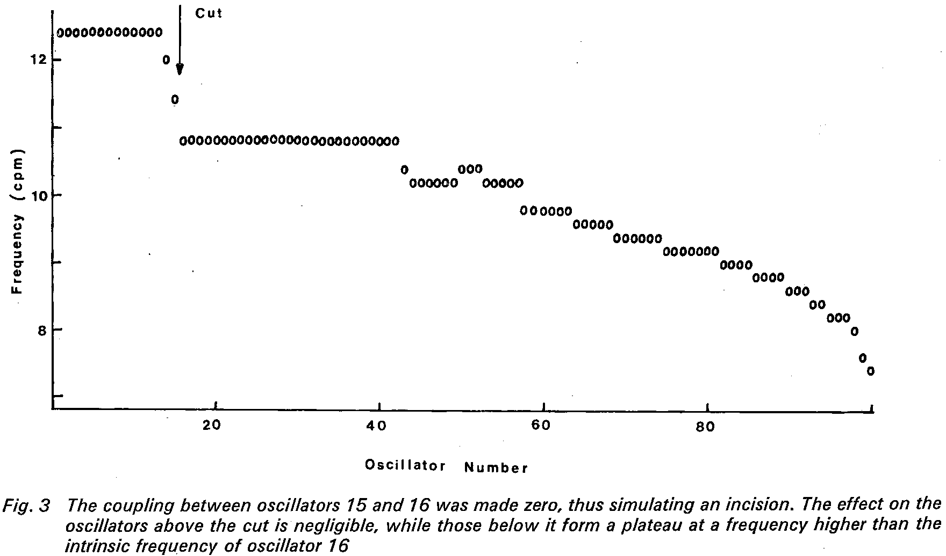
The oscillators above the cut were unaffected, but those below it have dropped in frequency and form a plateau at a frequency higher than the intrinsic frequency of oscillator 16 (HERMAN-TAYLOR and CODE 1971). To show the short-term frequency changes along the chain, Figs. 4a-c give successive 1 min averages for the model. If these 1 min averages are examined, small depressions in the average frequencies of groups of oscillators can be seen. The progress of the depression by labelled A may be followed in each successive minute in Figs. 4a-c.
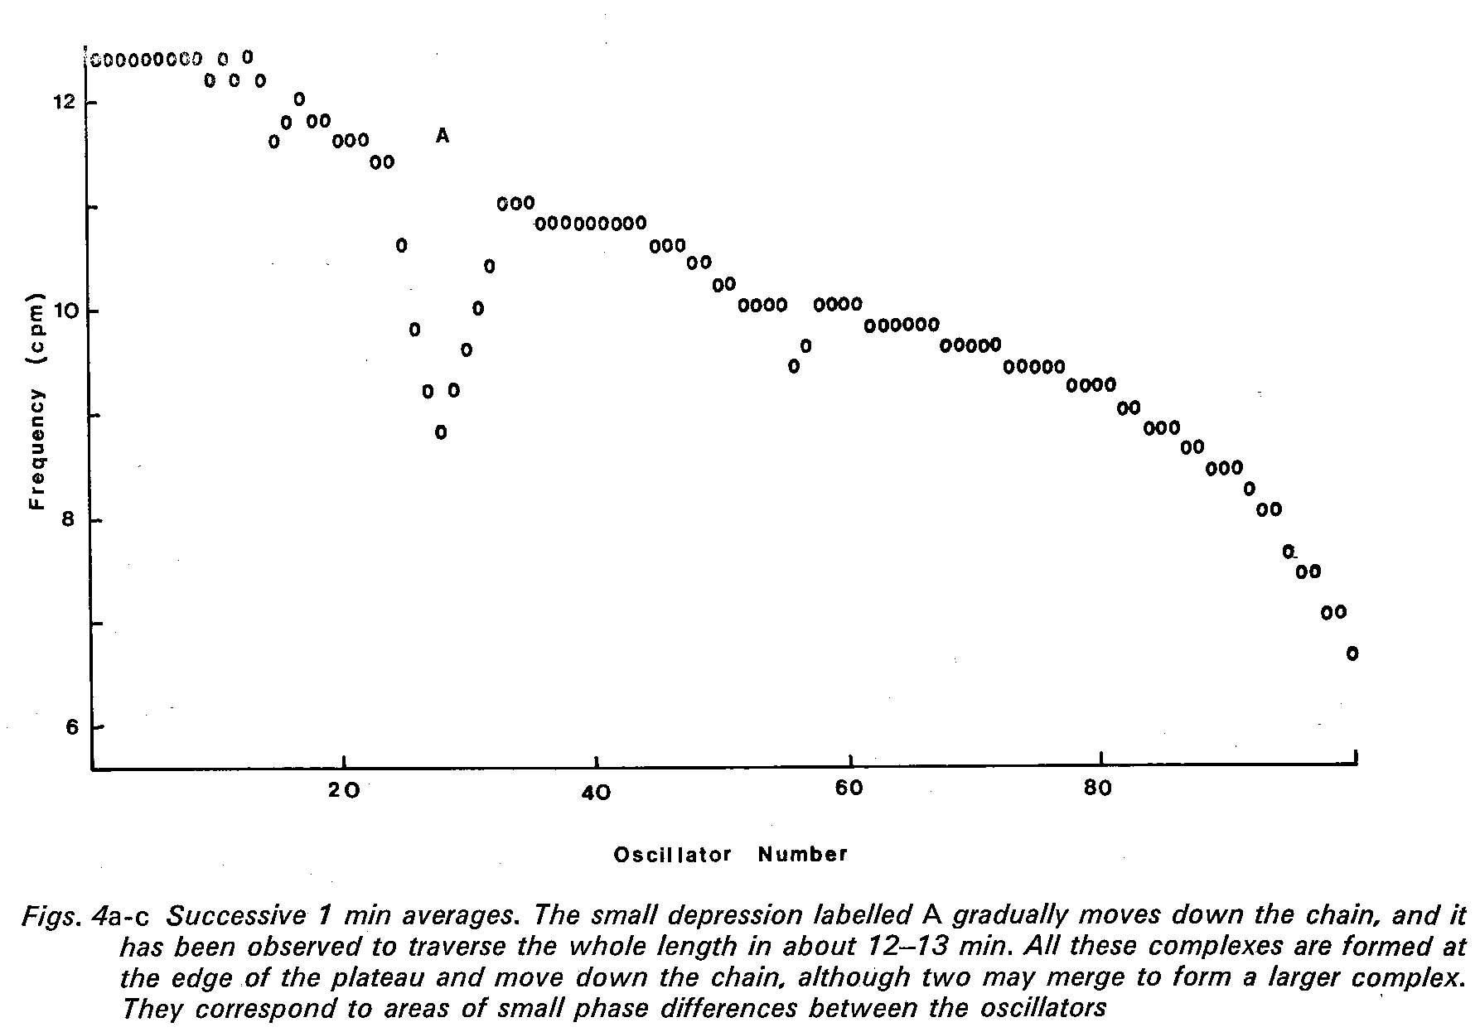
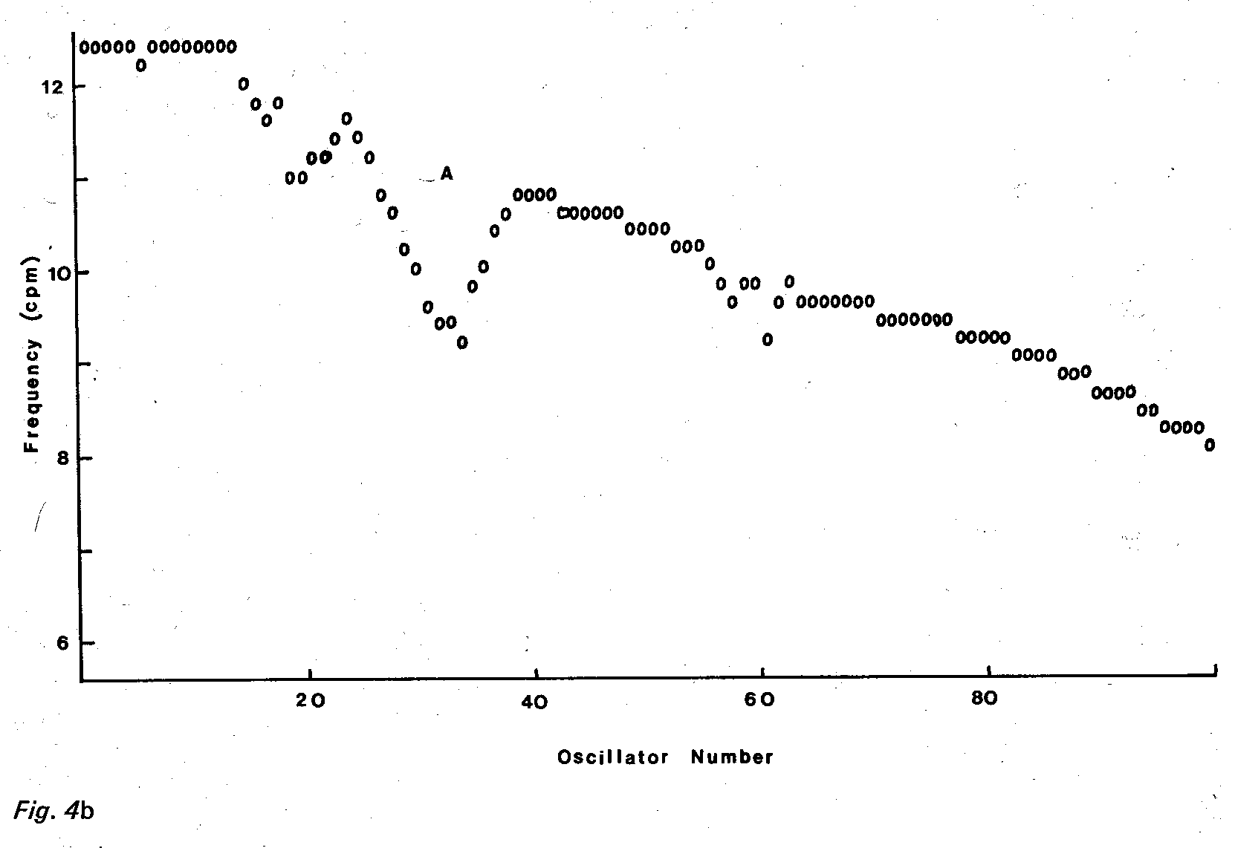
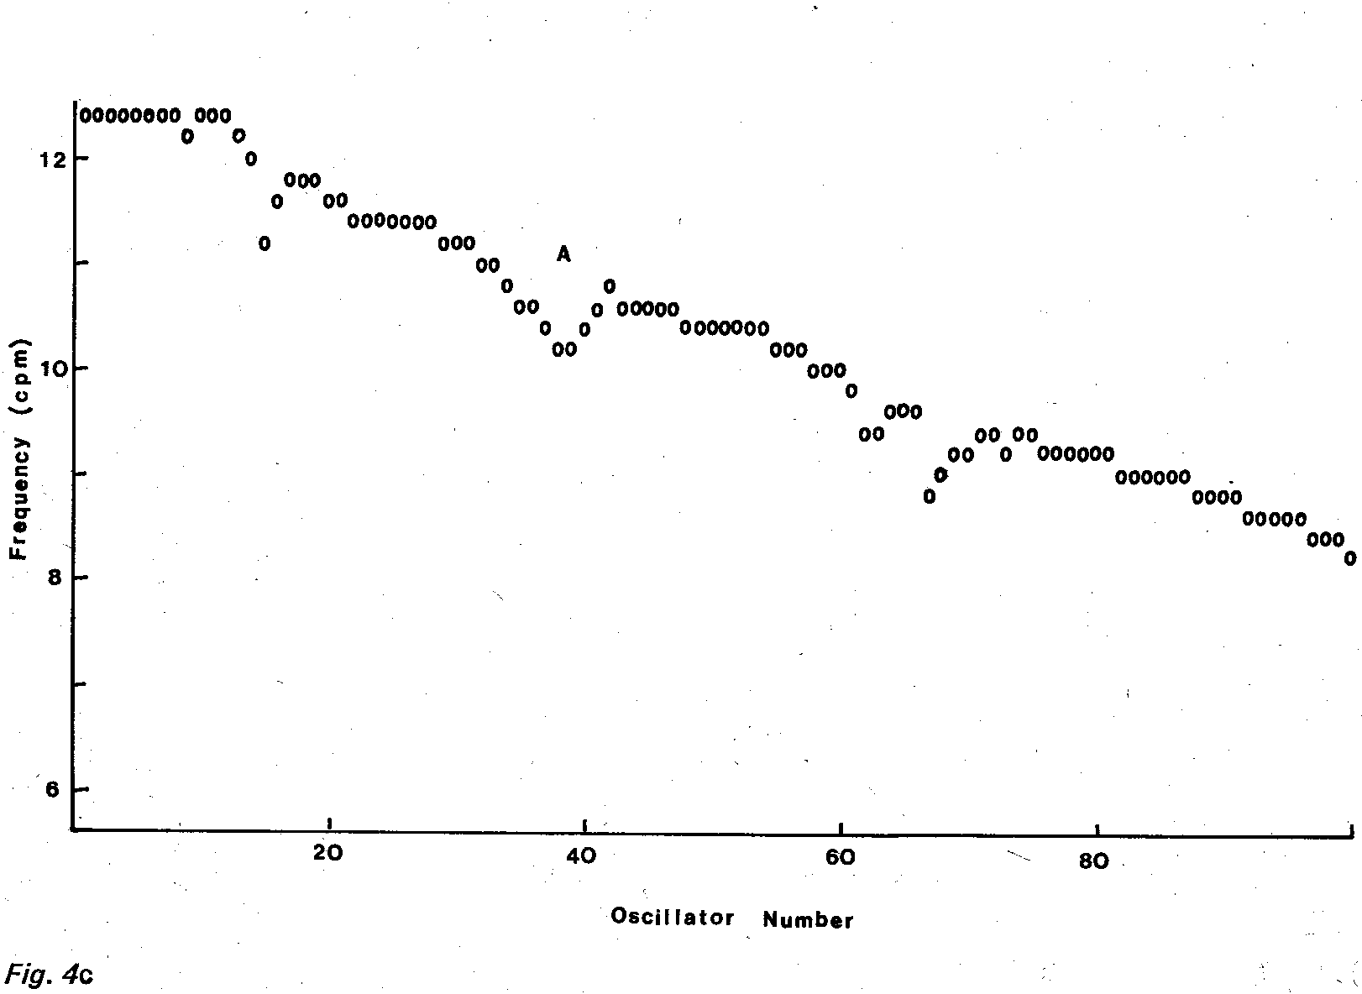
The oscillators with the depressed frequencies tended to have an inphase relationship, in contrast to the remaining oscillators which tended to have an antiphase relationship. Fig. 5 shows a. printout of the zero occurrences of outputs f or each of the oscillators during a 1 min run. Bands of oscillators entrained in an antiphase relationship can be seen traversing along the model. The frequency depression corresponded to a point in the model which had a rapid rate of change of phase passing through 0°. These points can be observed in Fig. 5 as the apex of the chevron patterns which linked the bands of temporarily entrained oscillators. It can also be seen that the first few oscillators in the frequency plateaus were entrained with a constant phase relationship. Further along the plateau there were variations in phase, but a constant average frequency which gave a frequency modulation or time-dependent phase shift effect as defined by DUTHIE et al. (1972).
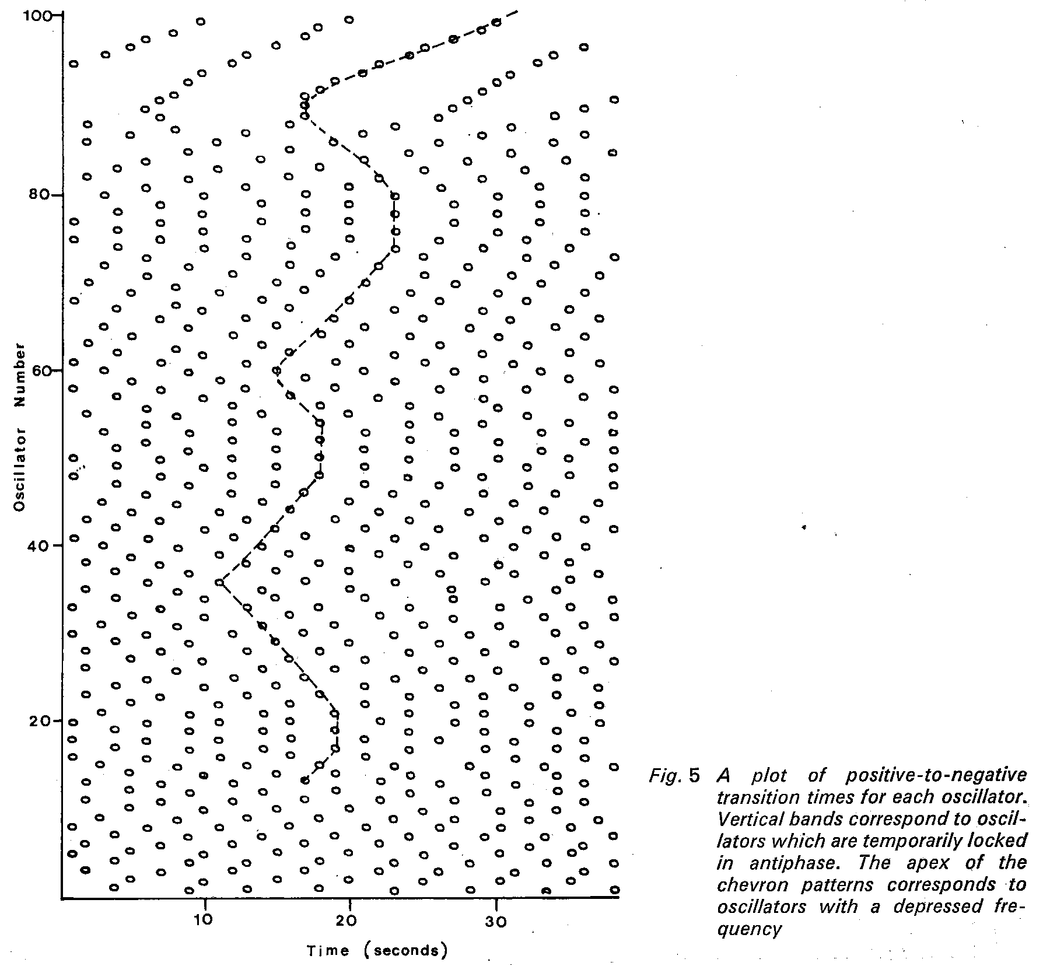
The frequency depression commenced at the distal end of the plateau and resulted from the fact that there was a difference in average frequency between the plateau oscillators and the 14th oscillator. This generated a beat frequency which determined the rate of generation of the frequency depressions. Fig. 6 shows the instantaneous frequency and phase for a 20-oscillator simulation in which three oscillators were entrained and the fourth generated the frequency depression. The manner in which there was a rapid rate of change of phase accompanied by the depression of frequency when the phase was 0⁰ can be seen from this Figure. Figs. 4a-c show that the depression A moved down the chain spontaneously and traversed the length in about 12 min. There were usually three or four such complexes occurring at anyone time and they were all created at the end of the initial plateau. They all reached the end of the chain, although two sometimes merged to form one larger complex.
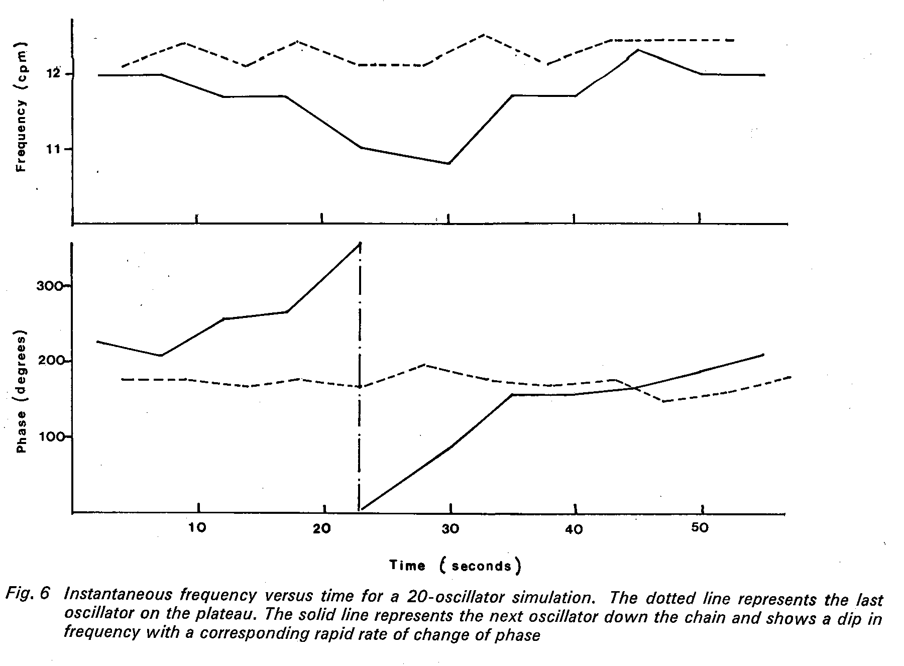
Discussion
The choice of a model based on relaxation oscillators follows the work of NELSEN (1968) and SARNA (1971), who showed that this type of model could reproduce more observed phenomena than that based on cable theory which had been suggested previously. In the model presented in this paper the Van der Pol equation with both λ and a² parameters set to 1.0 gives a wave shape most nearly resembling that in the human small bowel. Differences from other reported work arise on the question of coupling between the oscillators, for which unidirectional coupling (NELSEN, 1971) and bidirectional with a larger component backwards than forwards (SARNA, 1971) have been used. In the work presented here empirical studies on analogue and digital computers have led to the adoption of a coupling which decreases along the chain of oscillators in parallel with the decrease in the intrinsic frequency of the oscillators. In addition, the ratio of backward to forward coupling at 0·2 was also obtained by experimental simulations. Some justification for choosing these parameters is the production of a frequency plateau and time-dependent phase shifts in the upper part of the model which would correspond to the duodenum in man. The distal oscillators nos. 40 to 100 did not exhibit fixed frequency plateaus. This agrees with data from animal experiments and with the results of a few studies from two sites that have made in the terminal ileum.
The model utilises many more relaxation oscillators than previous models, which minimises the end effects caused by having an open-ended chain. It was also found that a single additional oscillator at the distal end of the chain set to 6 cycles/min and with upward coupling alone to represent the influence of the colon did not significantly alter the pattern of model behaviour.
An interesting phenomenon produced by the model was the spontaneous appearance of an area of inphase locking of adjacent oscillators combined with a small local decrease in frequency. This area appeared at the end of the frequency plateau in the 'duodenal' area of the model and progressed steadily down the rest of the oscillators. This has some of the characteristics of the 'electrical complex' reported by SZURSZWESKI (1969) in the canine intestine, but does not match it exactly. The data from the dog showed a band of intense spike activity which was followed by an increase in slow-wave activity and which took about 100 min to pass along the gut. In the model the rate of progress of the area of depressed frequency along the gut was much faster, taking about 12 min to traverse the small intestine. It was also noted that, whereas in the dog only one electrical complex was present in the gut at one time, up to three areas of reduced frequency could be travelling along the model simultaneously. It has been suggested that the orderly progression of the electrical complex may depend on the extrinsic innervation to the gut (CARLSON, BEDI and CODE, 1972), and it may be that this external control is necessary to regulate the spontaneous generation of such complexes by the relaxation oscillators themselves.
Many questions have been raised which have yet to be answered; in particular, the presence of any fluctuating frequency plateaus below the duodenal level in man awaits the acquisition of data from multiple recording points along the human gut. A similar technique would be necessary to ascertain the existence of any interdigestive myoelectrical complexes in humans. The fact that the extended model using relaxation oscillators presented here has characteristics compatible with such findings is a further stimulus to the perfection of a suitable method to obtain more data to confirm or refute these concepts.
Acknowledgments-The authors wish to thank Prof· H. L. Duthie Department of Surgery, University of Sheffield, for his help and advice in obtaining data and estimating the initial parameters for the mathematical model of the small intestine presented in this paper.
References
ALVAREZ, W. C. (1921) Early studies of the movements of the stomach and bowel. Handbook of physiology Chap. 79, Section 6. Vol. 4.
BROWN, B. H., KWONG, K. K. Ng. K., DUTHIE, H. L., WHITTAKER, G. E. and FRANKS, C. 1. (1971) Computer analysis and simulation of human gastroduodenal electrical activity. Med. Bioi. Eng. 9, 305314.
CHRISTENSEN, J., SCHEDL, H. P. and CLIFTON, J. A. (1964) The basic electrical rhythm of the duoedenum in normal human subjects and in patients with thyroid disease. J. Clin. Invest. 43, 1659-1667.
CHRISTENSEN, J., SCHEDL, H. P. and CLIFTON, J. A. (1966) The small intestinal basic electrical rhythm (slow wave) frequency gradient in normal men and in patients with a variety of diseases. Gastroenterology 50,309-315.
CHRISTENSEN, J., SCHEDL, H. P. and CLIFTON, J. A. (1966) Variations in the frequency of the human duodenal basic electrical rhythm in health and disease. Gastroenterology 61, 200-206.
DIAMANT, N. E., ROSE, P. K. and DAVISON, E. J. (1970) Computer simulation of intestinal slow wave frequency gradient. Amer. J. Physiol. 219, 1684-1690.
DUTHIE, H. L., KWONG, N. K., BROWN. B. H. and WHITTAKER, G. E. (1971) Pacesetter potential of the human gastroduodenal junction. Gut 12, 250-256.
DUTHIE H. L., BROWN, B. H., ROBERTSON-DUNN, B., KWONG, N. K., WHITTAKER, G. E. and WATERFALL, W. (1972) Electrical activity in the gastroduodenal area - slow waves in the proximal duodenum. Amer. J. Dig. Dis. 17,344-351.
HERMAN-TAYLOR. J. and CODE, F. C. (1971) Localisation of the duodenal pacemaker and its role in the organisation of duodenal myoelectric activity. Gut 12,40-47.
HOLOOAY, D. A .. VOLK, H. and MANDELL, J. (1958) Electrical activity of the small intestine with special reference to the origin of rhythmicity. Amer. J. Physiol. 195, 505-515.
LABO, G., LANDRANCHI, G. A., BORTOLOTTI, M., MIGLIOLO, M. and BARBARA, L. (1972) The electrical activity of the human intestine. Rendic, Gastroenterol. 4, 87-93.
LINKENS, D. A. Analytical solution of large numbers of mutually·coupled nearly sinusoidal oscillators. IEEE Trans. Circuit Theory. To be published.
NELSEN, T. S. and BECKER, J. C. (1968). Simulation of the electrical and mechanical gradient of the small intestine. Amer. J. Physiol. 214, 749-757.
SARNA, S. K., DANIEL, E. E and KINGMA, Y. J. (1971) Simulation of slow wave electrical activity of the small intestine. Amer. J. Physiol. 221,166-175.
SZCRSZWLSKI. J. H. (1969) A migrating electric complex of the canine small intestine. Amer. J. Physiol. 217, 1757-1763.
VAN DER POL, B. and VA'" DER MARK, J. (1928) The heartbeat considered as a relaxation oscillator and an electrical model of the heart. Phil. Mag. Suppl. 6, 763-775.
WATERFALL, W. E, BROWX, B. H., DUTHIE, H. L. and WHITTAKER, G. E (1972) The effects of humoral agents on the myoelectrical activity of the terminal ileum. Gut 13, 528·534.

